LAB 9:

Modeling a Sequence Controller

Professor Ronald Mehler

ECE 526L

Spring 2018

Garen Nikoyan

5/10/2018

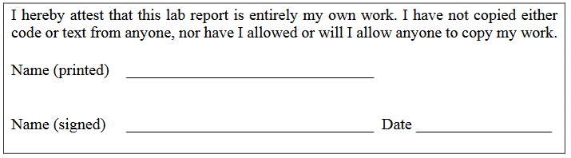

**Objective:**

The objective of this lab is to create a pair of modules that will later be used as the phase generator and sequence controller for a RISC CPU design. The phase generator will cycle through four instructions, FETCH, DECODE, EXECUTE, and UPDATE. Based on the OPCODE, the sequence controller will complete a certain function.

**Methodology:**

This lab was one of the most challenging designs. One of the things that made this lab

difficult is first trying to understand the process of the RISC-Y Processor and how it was going to function for the design to be built. One of the many interesting things about the RISC-Y processor is that it has 13 different outputs in which it will execute accordingly. The tasks to be executed will be according to the outputs that are active at the time of the simulation of the entire design.

The input also consists of many inputs, in which we call as the OPCODE this along with

the address is what allows what outputs to be active at a certain time. The opcodes can be found in the lab manual. Like mentioned earlier, each instruction takes four clock cycles of which are FETCH, DECODE, EXECUTE and UPDATE. One thing to note is that these phases are all enumerated types.

In the FETCH phase I enabled the instruction register. In the DECODE phase using a case statement I could give the instruction for every opcode along with every branch statement. In these cases, I set up the necessary ports that are going to be needed for that certain opcode.

For example, the case for ADD I enabled A_EN and B_EN which are which are the inputs for the A and B from the ALU. In the EXECUTE phase I enabled the corresponding elements that allow for the elements enabled in the decode phase. For example, in the decode phase since A_EN and B_EN were enabled, now for those to do their respective applications in the execute phase ALU_EN was enabled. The last cycle/phase out of the four cycles, here all we do is just make sure to set the outputs back to zero to be ready for the next task and set PC_EN high.

**Analysis:**

Looking at waveforms and the log, it can be seen that the modules seem to have worked correctly. The sequence controller is difficult to test until it is completely integrated within a processor. The necessary opcodes were ran through to ensure that each output toggled at least once. All of the opcodes were tested, with the exception of the ALU specific ones, where only ADD was tested. This was done to keep a smaller test bench, since if one of those worked correctly, we could safely assume the rest would as well. For STORE and LOAD, different addresses were tested to ensure that outputs were correct.

In Figure 1, the opcode LOAD is tested with address 64d and 65d. In Figure 2, LOAD is tested again with addresses 66d and 67d. IR_EN, PC_EN are toggling as expected, as are PDR_EN, RAM_OE, and RAM_CS, since these would be controlling the read and write from RAM. A_EN and B_EN are also toggling with their respective addresses.

In Figure 3, STORE is tested with address 64, and 67, followed by ADD and B, with address 67. During ADD, it can be seen that A_EN and B_EN go high, followed by ALU_EN, showing the ALU opcode works properly. In Figure 4, the branch opcodes are tested, albeit incorrectly. The flags were not set high after being initialized to 0, to see if PC_LOAD will properly follow the flags value.

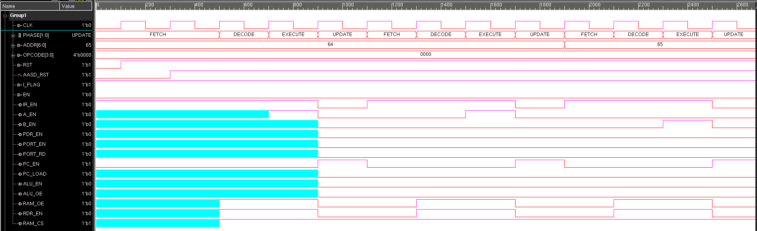

*Figure 1: LOAD at addr 64 and 65*

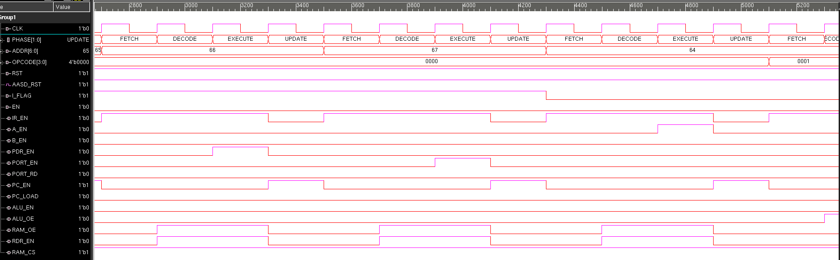

*Figure 2: LOAD at addr 66 and 67.*

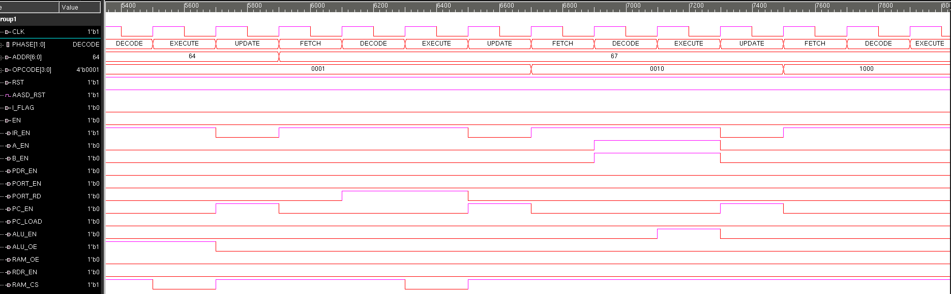

*Figure 3: STORE at addr 64 and 67, followed by ADD and B at addr 67.*

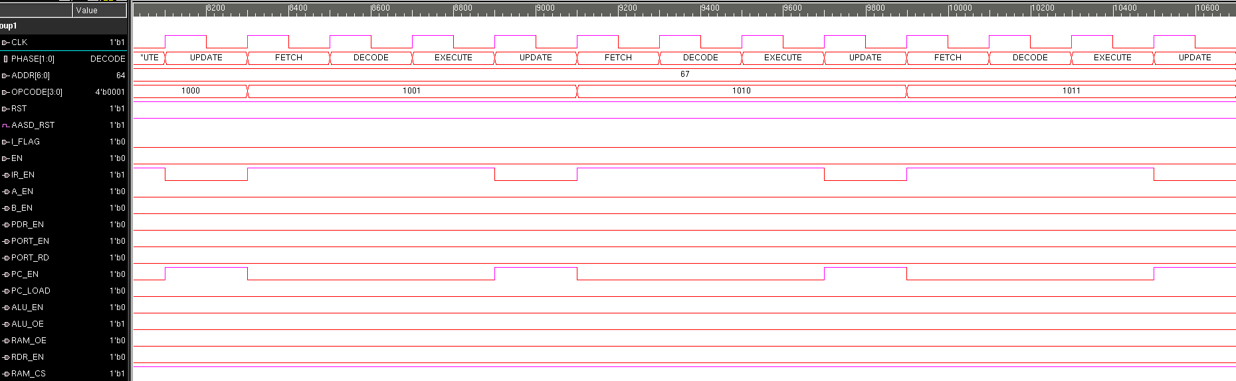

*Figure 4: BZ, BN,and BV at addr 67.*

**Modules:**

**toplevel.sv**

/***********************************************************************

*** ECE526L Experiment #9 Garen Nikoyan, Spring 2018

*** Modeling a Sequence Controller

************************************************************************

*** Filename: toplevel.sv Created by: Garen Nikoyan, 4/26/2018 ***

*** -Revision History

*** 4/26/2018: First draft

*** 5/8/2018: Changed branching in sequence_controller

*** 5/10/2018: Needs proper testing, error in test vectors, branch flags

************************************************************************

*** This module instantiates a sequence_controller, AASD, and phase_generator

*** It is meant to fit into a larger design, such as processor.

*** This module will provide the proper enable lines for certian opcodes

*** throughout FETCH, DECODE, EXECUTE, and UPDATE cycles

************************************************************************/

`timescale 1ns/100ps

`default_nettype none

package cycle_package;

typedef enum [1:0] {FETCH =0, DECODE = 1, EXECUTE = 2, UPDATE = 3} CYCLE;

endpackage

module toplevel(ADDR,OPCODE,I_FLAG,ZF,NF,OF,CF,IR_EN,A_EN,B_EN,PDR_EN,PORT_EN,PORT_RD,PC_EN,PC_LOAD,ALU_EN,ALU_OE,RAM_OE,RDR_EN,RAM_CS,CLK,RST,EN);

import cycle_package::*; //imports package

input [6:0] ADDR;

input [3:0] OPCODE;

input I_FLAG,ZF,NF,OF,CF,RST,CLK,EN;

output reg IR_EN,A_EN,B_EN,PDR_EN,PORT_EN,PORT_RD,PC_EN,PC_LOAD,ALU_EN,ALU_OE,RAM_OE,RDR_EN,RAM_CS;

CYCLE PHASE;

wire AASD_RST;

sequence_controller seq_cont(ADDR,OPCODE,PHASE,I_FLAG,ZF,NF,OF,CF,IR_EN,A_EN,B_EN,PDR_EN,PORT_EN,PORT_RD,PC_EN,PC_LOAD,ALU_EN,ALU_OE,RAM_OE,RDR_EN,RAM_CS);

AASD aasd_seq(AASD_RST,CLK,RST);

phaser phase_gen(CLK,AASD_RST,EN,PHASE);

endmodule

**sequence_controller.sv**

`timescale 1ns/100ps

`default_nettype none

package cycle_package;

typedef enum [1:0] {FETCH =0, DECODE = 1, EXECUTE = 2, UPDATE = 3} CYCLE;

endpackage

module sequence_controller(ADDR,OPCODE,PHASE,I_FLAG,ZF,NF,OF,CF,IR_EN,A_EN,B_EN,PDR_EN,PORT_EN,PORT_RD,PC_EN,PC_LOAD,ALU_EN,ALU_OE,RAM_OE,RDR_EN,RAM_CS);

import cycle_package::*;

input [6:0] ADDR;

input [3:0] OPCODE;

input CYCLE PHASE;

input I_FLAG,ZF,NF,OF,CF;

output reg IR_EN,A_EN,B_EN,PDR_EN,PORT_EN,PORT_RD,PC_EN,PC_LOAD,ALU_EN,ALU_OE,RAM_OE,RDR_EN,RAM_CS;

reg branches;

// Instruction set

localparam LOAD = 0,

STORE = 1,

ADD = 2,

SUB = 3,

AND = 4,

OR = 5,

XOR = 6,

NOT = 7,

B = 8,

BZ = 9,

BN = 10,

BV = 11,

BC = 12;

always @(PHASE,I_FLAG,ZF,NF,OF,CF,ADDR,OPCODE)

case (PHASE)

// FETCH

FETCH:

begin

IR_EN=1'b1;

PC_EN=1'b0;

end

// DECODE

DECODE:

begin

case (OPCODE)

LOAD:

begin

RAM_OE <= 1'b1;

RAM_CS <= 1'b1;

RDR_EN <= 1'b1;

end

STORE:

begin

if(ADDR==67) PORT_RD <= 1'b1;

else ALU_OE <= 1'b1;

end

ADD:

begin

A_EN = 1'b1;

B_EN = 1'b1;

end

SUB:

begin

A_EN = 1'b1;

B_EN = 1'b1;

end

AND:

begin

A_EN = 1'b1;

B_EN = 1'b1;

end

OR:

begin

A_EN = 1'b1;

B_EN = 1'b1;

end

XOR:

begin

A_EN = 1'b1;

B_EN = 1'b1;

end

NOT:

begin

A_EN = 1'b1;

B_EN = 1'b1;

end

endcase

end

// EXECUTE

EXECUTE:

begin

case (OPCODE)

LOAD:

begin

case (ADDR)

64: A_EN = 1'b1;

65: B_EN =1'b1;

66: PDR_EN <=1'b1;

67: PORT_EN <=1'b1;

endcase

end

STORE:

begin

RAM_CS <= 1'b0;

end

ADD:

begin

ALU_EN <=1'b1;

end

SUB:

begin

ALU_EN <=1'b1;

end

AND:

begin

ALU_EN <=1'b1;

end

OR:

begin

ALU_EN <=1'b1;

end

XOR:

begin

ALU_EN <=1'b1;

end

NOT:

begin

ALU_EN <=1'b1;

end

endcase

end

// UPDATE

UPDATE: begin

case(OPCODE)

B: PC_LOAD=1'b1;

BZ: PC_LOAD=ZF;

BN: PC_LOAD=NF;

BV: PC_LOAD=OF;

BC: PC_LOAD=CF;

default: PC_LOAD=1'b0;

endcase

IR_EN <= 1'b0;

A_EN = 1'b0;

B_EN = 1'b0;

PDR_EN <= 1'b0;

PORT_EN <= 1'b0;

PORT_RD <= 1'b0;

ALU_EN <= 1'b0;

ALU_OE <= 1'b0;

RAM_OE <= 1'b0;

RDR_EN <= 1'b0;

PC_EN=1'b1;

PC_LOAD=1'b0;

RAM_CS <= 1'b1;

end

// DEFAULT

default: begin

IR_EN <= 1'b0;

A_EN = 1'b0;

B_EN = 1'b0;

PDR_EN <= 1'b0;

PORT_EN <= 1'b0;

PORT_RD <= 1'b0;

ALU_EN <= 1'b0;

ALU_OE <= 1'b0;

RAM_OE <= 1'b0;

RDR_EN <= 1'b0;

PC_EN=1'b0;

PC_LOAD=1'b0;

RAM_CS <= 1'b1;

end

endcase

endmodule

**phaser.sv**

`timescale 1ns/100ps

`default_nettype none

package cycle_package;

typedef enum [1:0] {FETCH =0, DECODE = 1, EXECUTE = 2, UPDATE = 3} CYCLE;

endpackage

module phaser(CLOCK, RESET, EN, PHASE);

import cycle_package::*;

input CLOCK, RESET, EN;

output CYCLE PHASE;

always @(posedge CLOCK, negedge RESET) begin

if(!RESET)

PHASE <= PHASE.first();

else if(!EN)

PHASE <= PHASE.next();

else

PHASE <= PHASE;

end

endmodule

**AASD.sv**

`timescale 1ns/100ps

`default_nettype none

package cycle_package;

typedef enum [1:0] {FETCH =0, DECODE = 1, EXECUTE = 2, UPDATE = 3} CYCLE;

endpackage

module AASD(AASD_RST,CLOCK,RESET);

output reg AASD_RST;

input CLOCK,RESET;

reg Out1; //this is the wire for the output of the first FF

always @ (posedge CLOCK or negedge RESET) //allows 4 synchronous/asynchronous

if(!RESET)begin//asynchronous reset

Out1 <= 1'b0;

AASD_RST <= 1'b0;

end

else begin

Out1 <= 1'b1;

AASD_RST <= Out1;

end

endmodule

**Testbench:**

**toplevel_tb.sv**

`timescale 1ns/100ps

`default_nettype none

module toplevel_tb();

reg [6:0] ADDR;

reg I_FLAG,ZF,NF,OF,CF,RST,CLK,EN;

wire IR_EN,A_EN,B_EN,PDR_EN,PORT_EN,PORT_RD,PC_EN,PC_LOAD,ALU_EN,ALU_OE,RAM_OE,RDR_EN,RAM_CS;

enum reg[3:0] {LOAD, STORE, ADD, SUB, AND, OR, XOR, NOT, B, BZ, BN, BV, BC} OPCODE;

toplevel UUT(ADDR,OPCODE,I_FLAG,ZF,NF,OF,CF,IR_EN,A_EN,B_EN,PDR_EN,PORT_EN,PORT_RD,PC_EN,PC_LOAD,ALU_EN,ALU_OE,RAM_OE,RDR_EN,RAM_CS,CLK,RST,EN);

initial //makes the clock

begin

CLK=1'b0;

forever #10 CLK=~CLK;

end

initial

begin

$monitor("OUTPUTS: %d ns\tIR_EN=%d A_EN=%d B_EN=%d PDR_EN=%d PORT_EN=%d PORT_RD=%d PC_EN=%d PC_LOAD=%d ALU_EN=%d ALU_OE=%d RAM_OE=%d RDR_EN=%d RAM_CS=%d",$time,IR_EN,A_EN,B_EN,PDR_EN,PORT_EN,PORT_RD,PC_EN,PC_LOAD,ALU_EN,ALU_OE,RAM_OE,RDR_EN,RAM_CS);

$vcdpluson;

end

initial begin

$monitoroff;

RST = 1'b0; ADDR = 64; CF = 0; OF = 0; NF = 0; ZF = 0; I_FLAG = 1; OPCODE = 0; EN=1'b0; //initial states

#10 RST = 1'b1;

#110 $monitoron;

#70 ADDR = 65;

#80 ADDR = 66;

#80 ADDR = 67;

#80 I_FLAG = 0; ADDR = 64;

#80 OPCODE = 1; ADDR = 64;

#80 OPCODE = 1; ADDR = 67;

#80 OPCODE = 2;

#80 OPCODE = 8; CF = 0; OF = 0; NF = 0; ZF = 0;

#80 OPCODE = 9;

#80 OPCODE = 10;

#80 OPCODE = 11;

#80 OPCODE = 12;

$finish;

end

endmodule

**Log:**

Chronologic VCS simulator copyright 1991-2017

Contains Synopsys proprietary information.

Compiler version M-2017.03-SP1_Full64; Runtime version M-2017.03-SP1_Full64; May 8 21:12 2018

VCD+ Writer M-2017.03-SP1_Full64 Copyright (c) 1991-2017 by Synopsys Inc.

OUTPUTS: 120 ns IR_EN=1 A_EN=0 B_EN=0 PDR_EN=0 PORT_EN=0 PORT_RD=0 PC_EN=0 PC_LOAD=0 ALU_EN=0 ALU_OE=0 RAM_OE=0 RDR_EN=0 RAM_CS=1

OUTPUTS: 130 ns IR_EN=1 A_EN=0 B_EN=0 PDR_EN=0 PORT_EN=0 PORT_RD=0 PC_EN=0 PC_LOAD=0 ALU_EN=0 ALU_OE=0 RAM_OE=1 RDR_EN=1 RAM_CS=1

OUTPUTS: 150 ns IR_EN=1 A_EN=1 B_EN=0 PDR_EN=0 PORT_EN=0 PORT_RD=0 PC_EN=0 PC_LOAD=0 ALU_EN=0 ALU_OE=0 RAM_OE=1 RDR_EN=1 RAM_CS=1

OUTPUTS: 170 ns IR_EN=0 A_EN=0 B_EN=0 PDR_EN=0 PORT_EN=0 PORT_RD=0 PC_EN=1 PC_LOAD=0 ALU_EN=0 ALU_OE=0 RAM_OE=0 RDR_EN=0 RAM_CS=1

OUTPUTS: 190 ns IR_EN=1 A_EN=0 B_EN=0 PDR_EN=0 PORT_EN=0 PORT_RD=0 PC_EN=0 PC_LOAD=0 ALU_EN=0 ALU_OE=0 RAM_OE=0 RDR_EN=0 RAM_CS=1

OUTPUTS: 210 ns IR_EN=1 A_EN=0 B_EN=0 PDR_EN=0 PORT_EN=0 PORT_RD=0 PC_EN=0 PC_LOAD=0 ALU_EN=0 ALU_OE=0 RAM_OE=1 RDR_EN=1 RAM_CS=1

OUTPUTS: 230 ns IR_EN=1 A_EN=0 B_EN=1 PDR_EN=0 PORT_EN=0 PORT_RD=0 PC_EN=0 PC_LOAD=0 ALU_EN=0 ALU_OE=0 RAM_OE=1 RDR_EN=1 RAM_CS=1

OUTPUTS: 250 ns IR_EN=0 A_EN=0 B_EN=0 PDR_EN=0 PORT_EN=0 PORT_RD=0 PC_EN=1 PC_LOAD=0 ALU_EN=0 ALU_OE=0 RAM_OE=0 RDR_EN=0 RAM_CS=1

OUTPUTS: 270 ns IR_EN=1 A_EN=0 B_EN=0 PDR_EN=0 PORT_EN=0 PORT_RD=0 PC_EN=0 PC_LOAD=0 ALU_EN=0 ALU_OE=0 RAM_OE=0 RDR_EN=0 RAM_CS=1

OUTPUTS: 290 ns IR_EN=1 A_EN=0 B_EN=0 PDR_EN=0 PORT_EN=0 PORT_RD=0 PC_EN=0 PC_LOAD=0 ALU_EN=0 ALU_OE=0 RAM_OE=1 RDR_EN=1 RAM_CS=1

OUTPUTS: 310 ns IR_EN=1 A_EN=0 B_EN=0 PDR_EN=1 PORT_EN=0 PORT_RD=0 PC_EN=0 PC_LOAD=0 ALU_EN=0 ALU_OE=0 RAM_OE=1 RDR_EN=1 RAM_CS=1

OUTPUTS: 330 ns IR_EN=0 A_EN=0 B_EN=0 PDR_EN=0 PORT_EN=0 PORT_RD=0 PC_EN=1 PC_LOAD=0 ALU_EN=0 ALU_OE=0 RAM_OE=0 RDR_EN=0 RAM_CS=1

OUTPUTS: 350 ns IR_EN=1 A_EN=0 B_EN=0 PDR_EN=0 PORT_EN=0 PORT_RD=0 PC_EN=0 PC_LOAD=0 ALU_EN=0 ALU_OE=0 RAM_OE=0 RDR_EN=0 RAM_CS=1

OUTPUTS: 370 ns IR_EN=1 A_EN=0 B_EN=0 PDR_EN=0 PORT_EN=0 PORT_RD=0 PC_EN=0 PC_LOAD=0 ALU_EN=0 ALU_OE=0 RAM_OE=1 RDR_EN=1 RAM_CS=1

OUTPUTS: 390 ns IR_EN=1 A_EN=0 B_EN=0 PDR_EN=0 PORT_EN=1 PORT_RD=0 PC_EN=0 PC_LOAD=0 ALU_EN=0 ALU_OE=0 RAM_OE=1 RDR_EN=1 RAM_CS=1

OUTPUTS: 410 ns IR_EN=0 A_EN=0 B_EN=0 PDR_EN=0 PORT_EN=0 PORT_RD=0 PC_EN=1 PC_LOAD=0 ALU_EN=0 ALU_OE=0 RAM_OE=0 RDR_EN=0 RAM_CS=1

OUTPUTS: 430 ns IR_EN=1 A_EN=0 B_EN=0 PDR_EN=0 PORT_EN=0 PORT_RD=0 PC_EN=0 PC_LOAD=0 ALU_EN=0 ALU_OE=0 RAM_OE=0 RDR_EN=0 RAM_CS=1

OUTPUTS: 450 ns IR_EN=1 A_EN=0 B_EN=0 PDR_EN=0 PORT_EN=0 PORT_RD=0 PC_EN=0 PC_LOAD=0 ALU_EN=0 ALU_OE=0 RAM_OE=1 RDR_EN=1 RAM_CS=1

OUTPUTS: 470 ns IR_EN=1 A_EN=1 B_EN=0 PDR_EN=0 PORT_EN=0 PORT_RD=0 PC_EN=0 PC_LOAD=0 ALU_EN=0 ALU_OE=0 RAM_OE=1 RDR_EN=1 RAM_CS=1

OUTPUTS: 490 ns IR_EN=0 A_EN=0 B_EN=0 PDR_EN=0 PORT_EN=0 PORT_RD=0 PC_EN=1 PC_LOAD=0 ALU_EN=0 ALU_OE=0 RAM_OE=0 RDR_EN=0 RAM_CS=1

OUTPUTS: 510 ns IR_EN=1 A_EN=0 B_EN=0 PDR_EN=0 PORT_EN=0 PORT_RD=0 PC_EN=0 PC_LOAD=0 ALU_EN=0 ALU_OE=0 RAM_OE=0 RDR_EN=0 RAM_CS=1

OUTPUTS: 530 ns IR_EN=1 A_EN=0 B_EN=0 PDR_EN=0 PORT_EN=0 PORT_RD=0 PC_EN=0 PC_LOAD=0 ALU_EN=0 ALU_OE=1 RAM_OE=0 RDR_EN=0 RAM_CS=1

OUTPUTS: 550 ns IR_EN=1 A_EN=0 B_EN=0 PDR_EN=0 PORT_EN=0 PORT_RD=0 PC_EN=0 PC_LOAD=0 ALU_EN=0 ALU_OE=1 RAM_OE=0 RDR_EN=0 RAM_CS=0

OUTPUTS: 570 ns IR_EN=0 A_EN=0 B_EN=0 PDR_EN=0 PORT_EN=0 PORT_RD=0 PC_EN=1 PC_LOAD=0 ALU_EN=0 ALU_OE=0 RAM_OE=0 RDR_EN=0 RAM_CS=1

OUTPUTS: 590 ns IR_EN=1 A_EN=0 B_EN=0 PDR_EN=0 PORT_EN=0 PORT_RD=0 PC_EN=0 PC_LOAD=0 ALU_EN=0 ALU_OE=0 RAM_OE=0 RDR_EN=0 RAM_CS=1

OUTPUTS: 610 ns IR_EN=1 A_EN=0 B_EN=0 PDR_EN=0 PORT_EN=0 PORT_RD=1 PC_EN=0 PC_LOAD=0 ALU_EN=0 ALU_OE=0 RAM_OE=0 RDR_EN=0 RAM_CS=1

OUTPUTS: 630 ns IR_EN=1 A_EN=0 B_EN=0 PDR_EN=0 PORT_EN=0 PORT_RD=1 PC_EN=0 PC_LOAD=0 ALU_EN=0 ALU_OE=0 RAM_OE=0 RDR_EN=0 RAM_CS=0

OUTPUTS: 650 ns IR_EN=0 A_EN=0 B_EN=0 PDR_EN=0 PORT_EN=0 PORT_RD=0 PC_EN=1 PC_LOAD=0 ALU_EN=0 ALU_OE=0 RAM_OE=0 RDR_EN=0 RAM_CS=1

OUTPUTS: 670 ns IR_EN=1 A_EN=0 B_EN=0 PDR_EN=0 PORT_EN=0 PORT_RD=0 PC_EN=0 PC_LOAD=0 ALU_EN=0 ALU_OE=0 RAM_OE=0 RDR_EN=0 RAM_CS=1

OUTPUTS: 690 ns IR_EN=1 A_EN=1 B_EN=1 PDR_EN=0 PORT_EN=0 PORT_RD=0 PC_EN=0 PC_LOAD=0 ALU_EN=0 ALU_OE=0 RAM_OE=0 RDR_EN=0 RAM_CS=1

OUTPUTS: 710 ns IR_EN=1 A_EN=1 B_EN=1 PDR_EN=0 PORT_EN=0 PORT_RD=0 PC_EN=0 PC_LOAD=0 ALU_EN=1 ALU_OE=0 RAM_OE=0 RDR_EN=0 RAM_CS=1

OUTPUTS: 730 ns IR_EN=0 A_EN=0 B_EN=0 PDR_EN=0 PORT_EN=0 PORT_RD=0 PC_EN=1 PC_LOAD=0 ALU_EN=0 ALU_OE=0 RAM_OE=0 RDR_EN=0 RAM_CS=1

OUTPUTS: 750 ns IR_EN=1 A_EN=0 B_EN=0 PDR_EN=0 PORT_EN=0 PORT_RD=0 PC_EN=0 PC_LOAD=0 ALU_EN=0 ALU_OE=0 RAM_OE=0 RDR_EN=0 RAM_CS=1

OUTPUTS: 810 ns IR_EN=0 A_EN=0 B_EN=0 PDR_EN=0 PORT_EN=0 PORT_RD=0 PC_EN=1 PC_LOAD=0 ALU_EN=0 ALU_OE=0 RAM_OE=0 RDR_EN=0 RAM_CS=1

OUTPUTS: 830 ns IR_EN=1 A_EN=0 B_EN=0 PDR_EN=0 PORT_EN=0 PORT_RD=0 PC_EN=0 PC_LOAD=0 ALU_EN=0 ALU_OE=0 RAM_OE=0 RDR_EN=0 RAM_CS=1

OUTPUTS: 890 ns IR_EN=0 A_EN=0 B_EN=0 PDR_EN=0 PORT_EN=0 PORT_RD=0 PC_EN=1 PC_LOAD=0 ALU_EN=0 ALU_OE=0 RAM_OE=0 RDR_EN=0 RAM_CS=1

OUTPUTS: 910 ns IR_EN=1 A_EN=0 B_EN=0 PDR_EN=0 PORT_EN=0 PORT_RD=0 PC_EN=0 PC_LOAD=0 ALU_EN=0 ALU_OE=0 RAM_OE=0 RDR_EN=0 RAM_CS=1

OUTPUTS: 970 ns IR_EN=0 A_EN=0 B_EN=0 PDR_EN=0 PORT_EN=0 PORT_RD=0 PC_EN=1 PC_LOAD=0 ALU_EN=0 ALU_OE=0 RAM_OE=0 RDR_EN=0 RAM_CS=1

OUTPUTS: 990 ns IR_EN=1 A_EN=0 B_EN=0 PDR_EN=0 PORT_EN=0 PORT_RD=0 PC_EN=0 PC_LOAD=0 ALU_EN=0 ALU_OE=0 RAM_OE=0 RDR_EN=0 RAM_CS=1

OUTPUTS: 1050 ns IR_EN=0 A_EN=0 B_EN=0 PDR_EN=0 PORT_EN=0 PORT_RD=0 PC_EN=1 PC_LOAD=0 ALU_EN=0 ALU_OE=0 RAM_OE=0 RDR_EN=0 RAM_CS=1

$finish called from file "SeqConTB.sv", line 44.

$finish at simulation time 10700

V C S S i m u l a t i o n R e p o r t

Time: 1070000 ps

CPU Time: 0.210 seconds; Data structure size: 0.0Mb

Tue May 8 21:12:41 2018

**Conclusion:**

Everything in this lab seems to have worked as expected, except for the branches opcodes which was tested improperly. The modules created for this lab will be truly put to the test in Lab 10, when they are integrated within a processor.